**Injection Moulding Design**

After shredding, plastic granules are easier to melt. The shreds of plastic can be fed into past some form of heating element and then pushed directly into the specified mould to be set. Creating a desired product.

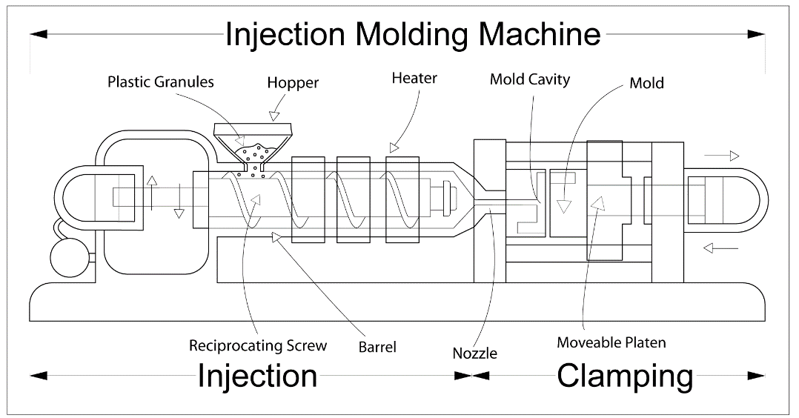The general process of heating is not as simple as at first thought, the plastic must be evenly heated and not set in any section before the mould has been filled. Creating a small window between the time the heating ends and the setting of the plastic begins.

Image sources from - https://www.avplastics.co.uk/what-is-injection-moulding#:~:text=Material%20granules%20for%20the%20part,the%20configuration%20of%20the%20cavity.

A screw mechanism is used to facilitate the heating of the plastic, with a set number of heating bands providing the gentle temperature increase required to melt the plastic effectively. The short distance between the mould and the nozzle at the end of the screw allow for a seamless moulding process, ensuring moulding errors, such as deformations, are kept to a minimum.

Precious Plastics injection moulding machine is a vertical hand operated type of injection, the cheapest method of injection moulding. The screw is not used in this type of moulding, a plunger is used instead, making it easier to use by hand. A large problem lies with the capacity of this type of machine, being hand operated the machines capacity is supposedly between 0.5-2oz of plastic. <https://plustio.blogspot.com/2017/06/vertical-hand-injection-machine.html>.

The precious plastics machine seems too small to use within our operation, a slightly more industrial model will likely be required.

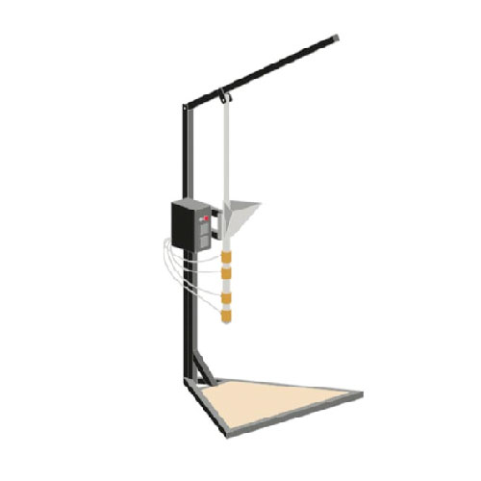In order to expand the current injection moulding machine listed by precious plastics, the size of the larger items, the recycle collection bins and the water collection tanks will need to be known. Making the machine too big will simply be a waste of money.

If the design is kept to a minimum size, it is hoped that the solution to the problem is simple, fixed by:

* Increasing the inside diameter of the injection tube, allowing for a greater volume of melted plastic.
* An increased exposure to the heating element bands (shown in gold), more plastic will take more time to melt. This does require more energy.
* Top hand operated lever will be extended, longer leaver will mean less force required by the operator to push the plastic out of the injection tube. Accounting for the increased amount of plastic.

Will need to do calculations to find the volume and extra energy required, do not know said calculations are required for the report.